Contents
2 Theoretical views on social positions, social interactions, and social cohesion 1
2.1 Concept of Social Cohesion 1
2.2 Antecedents of social cohesion (Macro) 3
2.3 Conceptualizing social structure 5
2.4 Social positions and interpersonal expectations (individual-to-others) 7
2.4.1 Socioeconomic Status 8
2.4.2 Religion and Migration 8
2.4.3 Values and Political Ideology 9
2.4.4 Is and how similarity affect social cohesion? 10
2.5 Hypotheses 12

Theoretical views on social positions, social interactions, and social cohesion

Concept of Social Cohesion
A foundational question in sociological thought has been which forces impede societies from falling apart and holding them together. This inquiry has been tackled in the seminal work of Emile Durkheim on organic solidarity as the moral foundation for societal bonds (Durkheim, 2012 [1879]) or by Georg Simmel on the role of exchange and trustworthy social interactions as a constituent element that, without it, “society itself would disintegrate.” (Simmel, 2004 [1900]). Building on their theoretical, more recent sociological scholarship has coined the concept of social cohesion, however, not without contestation (Janmaat, 2011). In this regard, there have been different approaches to the study of “what holds societies together” in the social sciences, with differences in operationalization leading to a certain degree of conceptual conflation (Chan et al., 2006).As an effort to clarify the conceptual debate recent works have sought to reinforce the concept, leading to a significant convergence around its conceptual core (Dickes et al., 2010; Dickes & Valentova, 2013; Schiefer & van der Noll, 2017). This focus stems from the need to distinguish the constituent elements of cohesion from its causes and consequences (Chan et al., 2006; Delhey et al., 2023). Conceptually, social cohesion is argued to be a collective attribute or macro-level property of higher units such as countries or regions (Chan et al., 2006; Delhey et al., 2023; Dickes & Valentova, 2013). However, in practice, most studies on social cohesion have relied on aggregating micro-level data—specifically individual attitudes and behaviors—to describe these societal characteristics (Dickes et al., 2010; Dickes & Valentova, 2013; Schiefer & van der Noll, 2017)
The literature has converged on a core of constituent components, such as social relations (networks, trust, and acceptance of diversity), identification with the social entity (belonging and attachment), and orientation toward the common good (solidarity and cooperation) (Delhey et al., 2023; Schiefer & van der Noll, 2017). Chan et al. (2006) suggest organizing these constituent dimensions across two axes. First, the horizontal axis refers to linkages between individuals and groups within society. Second, the vertical axis refers to linkages between individuals and societal institutions. Additionally, a distinction is made between the subjective components of cohesion –attitudes or perceptions toward other individuals or groups in society, and the objective dimension – observable behaviors within social associations between individuals, as well as other regarding behaviors such as political or civic engagement (see Chan et al., 2006, p. 294).
Similarly, Grunow et al. (2023) have attempted to summarize the constituent elements of social integration as a neighbor concept of social cohesion, recognizing the conflation around concepts in the literature (p. 4). Social integration relies on the quality of social interactions between individual actors as fundamental to constituting society as a unit to a sufficient degree that maintains social order (Grunow et al., 2023, p. 8). The typology organizes "ingredients" for social integration into two main domains. Accordingly, there are distinct co-orientations among actors, such as beliefs or attitudes, and co-interactions arising from interdependent individual activities.

The first co-orientation is consensus, which encompasses both evaluative and normative orientations regarding what is considered desirable and obligatory, as well as a cognitive orientation about the factual nature of the world. The emphasis is placed on observing the extent to which members of a society share these orientations and how they express them. Next is trust, which refers to the belief that social actors—be they individuals, groups, or organizations—can "keep promises and agreements" and that, even if they act in their self-interest, they do not harbor "unfriendly" intentions towards others or engage in "unruly" behaviors, such as stealing instead of buying. The number of trustworthy members within a society can indicate the level of trust in that society. The first co-interaction is conformity, defined as adherence to norms, whether formal or informal, regardless of whether compliance is enforced, incentivized, or driven by identification with them. To assess conformity, the total number of members in society and the degree of their adherence to established norms are typically used. The final ingredient of co-interaction is cooperation, understood as the basic pooling of social resources within a community, ranging from recognizing potential opportunities or needs for collaboration to the likelihood of forming reciprocal or altruistic bonds among social actors. Thus, social integration is associated with the "number and extent of cooperative ties" among members of society, as well as the intensity and solidaristic nature of these cooperations. In contrast, isolated egoistic behavior is a sign of disintegration, while forced, non-voluntary actions indicate over-integration.

The typology above described explicitly suggests that social integration should be understood as the “balanced mid-level between the two sides of problematic integration” (p. 11) of total disintegration and total over-integration. It is possible to characterize social integration not simply as the “sum” of all the ingredients in an additive “more integrated” society. Rather, these describe the parts of a social mechanism (Grunow et al., 2023, p. 16). Echoing the social cohesion scholars, the consensus, trust, conformity and cooperation should not be acritical maximized rather it represents a middle-point or balance between them. This tackles the idea that gradient of ‘cohesiveness’ does not imply that societies should look at it as a normative imperative to develop but the combination of the objective and subjective constituent elements positioned along the vertical and horizontal dimension.
The typology above described explicitly suggests that social integration should be understood as the “balanced mid-level between the two sides of problematic integration” (p. 11) of total disintegration and total over-integration. It is possible to characterize social integration not simply as the “sum” of all the ingredients in an additive “more integrated” society. Rather, these describe the parts of a social mechanism (Grunow et al., 2023, p. 16). Therefore, the maximization of ingredients regarding co-interactions and co-orientations is not what social integration implies; rather, it implies a balance between them. Their argument follows a similar rationale to the idea that the gradient of ‘cohesiveness’ does not imply that societies should view it as a normative imperative to develop, but rather the combination of the objective and subjective constituent elements positioned along the vertical and horizontal dimensions (Chan et al., 2006; Delhey et al., 2023).
Here, we understand social cohesion as a characteristic of a social unit, but it is defined in terms of the social interactions within it. Therefore, the social interactions within the unit are the constituent elements of social cohesion. We clearly state that the characteristics of the social unit, such as inequality, heterogeneity, and institutions (formal or informal), are understood as explanatory factors of cohesiveness, since they affect social interactions.
In this study, we focus on the horizontal dimension of social cohesion. Particularly, by examining the individual (subjective) expectations toward different social positions as a constitutive component in the formation of social associations within and between groups.

Antecedents of social cohesion (Macro)
In this section we aim to briefly summarize what are relevant societal characteristics that are expected to affect horizontal social cohesion but focused to a greater extent on the subjective component but also considering related-behavioral expressions. Therefore, we do not review relevant literature on vertical social cohesion focused on public views on public institutions and political authorities, nor the behavioral expressions within the political system.
The scholarly discussion on social cohesion has clearly distinguished constituent elements from their causes. Among the factors that affect social cohesion—either as promoters or inhibitors—scholarly attention has primarily focused on unit-level conditions that influence the constituent elements of social cohesion. Delhey et al. (2023) suggest four domains that are directly associated with social cohesion, including affluence, inequality, value climate and ethnic heterogeneity (p.12). Building on their findings, we organize the factors into four domains related to societal characteristics in socio-economic, sociocultural, institutional and values. We also recognize that the absence of an overarching theory of social cohesion that brings all domains together, while the theoretical mechanism for domain-specific effects is mainly focused on constituent elements rather than cohesiveness itself.

Scholarly on the relationship between economic conditions and social cohesion has stressed focused on two characteristics.
On the one hand, economic affluence of society is the overall pool of resources available within it.
On the other hand, economic inequality as how the available resources in society are distributed among its members.
The socioeconomic domain encompasses economic prosperity and inequality. Economic inequality is identified as an antecedent that exerts a corrosive impact on cohesion, primarily by undermining interpersonal trust and impeding participation (Schiefer & Noll, 2017; Portes & Vickstrom, 2011). Research suggests that while moderate income inequality may be compatible with cohesion, extreme inequality triggers domain-specific erosion (Delhey et al., 2023). The theoretical mechanism linking inequality to cohesion operates through status differentiation: when resources are distributed inequitably, individuals at different ends of the hierarchy do not perceive themselves as sharing a common fate (Uslaner & Brown, 2005).
Research on the link between sociocultural dimensions and social cohesion stressed the role of heterogeneity on social interactions within society.

Second, the sociocultural domain concerns migration, ethnic heterogeneity, and religious diversity. The effect of ethno-racial heterogeneity on cohesion is highly relevant (Delhey et al., 2023; Portes & Vickstrom, 2011). The most significant risk comes from unequal diversity—where heterogeneity is coupled with high segregation and inequality—rather than diversity alone (Portes & Vickstrom, 2011). Theoretical accounts suggest that diversity can erode trust by reducing shared social networks and increasing perceived threat, though strong institutions can moderate these effects.
Third, the political domain encompasses democracy, institutional quality, and corruption. Strong, fair, and inclusive institutions function as crucial moderators by undergirding the systemic integration necessary for complex modern societies, thereby neutralizing or reversing negative correlations between diversity and trust (Portes & Vickstrom, 2011; Delhey et al., 2023). Conversely, corruption and weak governance undermine both vertical trust (in institutions) and horizontal trust (among citizens).
Fourth is the value consensus domain. There is one study that has addressed how (macro) value consensus (using Schwartz human values), among European countries, is associated with social trust. The finding is a positive relation between macro-value consensus (correlation) and social/ generalized trust (Beilmann & Lilleoja, 2015).
This study focuses on the subjective-horizontal dimension of social cohesion, operationalized as cross-group solidarity—the expectation that individuals from different social positions (defined by status, religion, nationality, ideology, or values) will act cooperatively and with mutual regard.
“that there are differences in social positions, that there are social relations among these positions, and that people's positions and corresponding roles influence their social relations.” (Blau, 1977, p. 27)
This concept draws on the Durkheimian tradition of organic solidarity and Blau's (1977) emphasis on social associations across groups as the foundation of macrosocial integration.

Conceptualizing social structure
As a starting point for conceptualizing social structure, I draw on the macrosociological theory of Peter Blau (1977). Blau conceptualizes social structure as the multidimensional distribution of a population among social positions defined by parameters—attributes that both classify individuals and shape their social associations. Parameters are of two types: nominal, which divide people into groups with distinct boundaries (e.g., race, religion), and graduated, which order them along status hierarchies (e.g., income, education). From these distributions derive the core structural properties of heterogeneity (the degree to which a population is spread across nominal categories) and inequality (the degree of status disparity along graduated dimensions). Crucially, Blau emphasizes how parameters relate to one another: intersecting parameters, which are weakly correlated, compel intergroup associations and thereby integrate society, whereas consolidated parameters, which are strongly correlated, reinforce social boundaries and impede intergroup contact.
This framework treats social structure strictly in terms of population distributions and their interrelations, deliberately abstracting from cultural meanings, values, and individual dispositions. It thereby provides a formal foundation on which one can layer additional dimensions—such as the cultural stratification arising from the distribution of political ideologies and human values—without violating the underlying logic of structural analysis.
Objective positions
To understand how these societal conditions translate into individual-level dispositions, I draw on Peter Blau's (1977) macrosociological theory of social structure. For Blau, societies can be understood as the structure of social relations between individuals. These relations are what can structurally integrate societies, and their configuration depends on the distribution of populations across two fundamental types of parameters.
Blau distinguishes between graduated parameters (e.g., income or education) and nominal parameters (e.g., religion or ethnicity). At the macrosocial level, graduated parameters are linked to inequality—the distribution of populations along hierarchical dimensions of status and resources. Nominal parameters are related to heterogeneity—the distribution of populations across nominal groups without inherent hierarchy. As Blau (1977, p. 32) states: "Both inequality and heterogeneity, the two forms of differentiation, are barriers to social intercourse, on the assumption that proximate status and common group membership promote social associations."
The central question guiding this approach is: "How do heterogeneity and inequality affect intergroup and interstratum relations?" (Blau, 1977). The answer lies in the intersection or consolidation of parameters: "the degree to which parameters intersect or alternatively consolidate differences in social positions through their strong correlations, reflects the most important structural conditions in a society, which have crucial consequences for conflict and for social integration" (Blau, 1977, p. 32). For Blau, these are objective demographic parameters—measurable characteristics of populations that shape the opportunities for social associations, while explicitly keeping sociability preferences, norms, and values out of his conceptualization of the social structure.
Subjective positions
Despite the theory of social structure by Blau (1977) providing a framework for understanding how objective population parameters affect social associations, it also stresses that social relations rests on "actual social associations between people in different segments, not on functional interdependence or common values." (p.33), there are more recent social cohesion scholarships that have considered the extent of subjective characteristics, such as world views and values, jointly with objective characteristics may also play a role in the formation of social associations.
In highly differentiated contemporary societies, values have been considered in the study of social cohesion as a relevant source of cultural distinction. Building on the work of cultural stratification scholarship, Groh-Samberg et al (2014) discuss the cultural dimension in the formation of social milieus – as latent groups resulting from the intersection of vertical stratification and horizontal value-based distinctions, arguing that shared lifestyles, values, and worldviews create patterns of social closure and affiliation that are not reducible to objective class positions. This social cohesion literature has explicitly considered human values as relevant subjective cultural dimensions in the formation of social associations between individuals. The theory these studies have relied on is Schwartz's (1992) human value model, which defines values as deep-seated motivational orientations that shape how individuals evaluate others and prioritize different forms of social engagement. In this sense, values should be distinguished from attitudes as a "fixed set of enduring beliefs that refer to desirable abstract and motivational goals that serve as guiding principles in a person's life" (Kulin and Svallfors, 2013, p. 157).
The role of world views, such as ideological preferences, has been stressed in the scholarly discussion on social integration. This perspective states that being integrated into society does not imply one-to-one confirmation of everyone’s world views, but the possibility of openly debating conflicting ideas in which the balance or “space between” disintegration and overintegration relies “democratic” conflict (Grunow et al., 2023).

What I want to say, that conflictive world views in democratic context are important to study from a social cohesion perspective for the following reasons:
part of the political community of a society (or tend to)
political preferences enclosure worldviews about relevant economic and cultural topics
There has been increasing attention in the scholarly literature on social cohesion to the tensions and distinctions between left- and right-wing political preferences (Schubach & Thielmann, 2025).
Political ideology (e.g., left, right, or undefined)—a subjective orientation that signals affiliation with broader political projects and communities of interpretation.

Political ideology can function as a nominal parameter: individuals categorize others as "like me" or "not like me" based on perceived ideological proximity, even in the absence of objective group markers.
Given the above reasoning, it is reasonable to consider whether values and political beliefs play a role in social associations.
In this study to understand how different types of social positions—both objective (graduated and nominal parameters) and subjective (values and political ideology)—are linked with the subjective horizontal dimension of social cohesion, specifically related to the interpersonal positive expectations about other members of society.

“in modernity is not based on a society-wide “groupthink” (Janis 1972), with everybody confirming everybody else’s perspective but, on the contrary, on an opening of conflicting perspectives—a point strongly emphasised by Nicole Deitelhoff and Cord Schmelzle in their contribution to this special issue.”

Social positions and interpersonal expectations (individual-to-others)
Theories of social cohesion typically treat it as a macro-level phenomenon—an emergent property of societies, regions, or communities. Empirically, however, these theories rely on aggregated survey data to capture individual attitudes and behaviors. What remains underexplored is the micro-level process: how do individuals, situated in particular social positions, develop expectations (e.g., trust, cooperation) toward individuals or groups in diverse social positions? This question is particularly relevant for my theoretical framework, which draws on Blau's (1977) insight that social structure is fundamentally about the associations between people in different social positions. Understanding how population parameters translate into individual-level associative dispositions requires engaging with theories and empirical evidence from across the social sciences.
In what follows, I organize the micro-level mechanisms according to the typology introduced above. Specifically, I examine how each type of social position—objective-graduated, objective-nominal, subjective-nominal (ideology), and subjective-value-based—shapes individual expectations towards others on diverse social positions. For each, I review relevant theories and empirical findings that illuminate the mechanisms linking position to disposition.

Socioeconomic Status
The relationship between socioeconomic status and out-group trust operates through multiple mechanisms. First, status distance discourages social intercourse. Blau (1977, p. 43) proposes that "status distance discourages social associations," and that "reductions in inequality diminish the impact of status on social associations." The implication is that individuals are more likely to form trusting relationships with those who are proximately in status; large status gaps create barriers to mutual understanding and shared experience.
Second, resource signaling suggests that individuals use socioeconomic cues to infer trustworthiness. Higher-status individuals may be perceived as more trustworthy because they are seen as having more to lose from opportunistic behavior, or because they embody cultural capital and competence (Salgado et al., 2021). Conversely, lower-status individuals may face stigmatization and distrust due to negative stereotypes associating poverty with moral failure or unpredictability.
Experimental studies show that individuals display higher trust toward higher-status others in economic games (Balliet et al., 2018). Survey research consistently finds positive associations between own socioeconomic status and generalized trust, though the causal direction remains debated (Uslaner & Brown, 2005). In the Chilean context, Salgado et al. (2021) find that lower-status individuals tend to distrust those with higher incomes, suggesting that status hierarchies generate asymmetric trust patterns.

Religion and Migration
Nominal parameters—such as religion, ethnicity, or migratory status—structure social associations primarily through ingroup bias and outgroup stereotyping. Social identity theory (Tajfel & Turner, 1979) posits that individuals derive part of their self-concept from group memberships, leading to favoritism toward ingroups and discrimination against outgroups. These biases operate even in the absence of objective conflict, and they are often activated automatically and unconsciously.
Three mechanisms are particularly relevant. First, categorization simplifies the social world by grouping individuals into "us" and "them." Second, social learning transmits stereotypes and prejudices through family, peers, and media. Third, perceived threat—whether realistic (competition for resources) or symbolic (threat to cultural values)—amplifies outgroup distrust (Stephan & Stephan, 2000).
However, intergroup contact theory (Allport, 1954; Pettigrew & Tropp, 2006) offers a countervailing mechanism: positive contact with outgroup members, under appropriate conditions (equal status, common goals, institutional support), reduces prejudice and increases trust. The effects of nominal parameters on trust are therefore not deterministic; they depend on opportunities for contact and the structural conditions (segregation vs. integration) in which groups interact.
Regarding religion, Dingemans and Van Ingen (2015) find that regular religious attendance increases generalized trust by providing functional social networks, while high individual religiosity can reduce trust in outgroups. Thunström et al. (2021) document strong ingroup bias in the United States: Christians trust other Christians more than Muslims or nonbelievers. Regarding migration, Portes and Vickstrom (2011) show that the corrosive effects of ethnic heterogeneity on trust are contingent on inequality and segregation; in contexts of unequal diversity, distrust is higher.

Values and Political Ideology
Political ideology
Political ideology—the self-placement along a left-right or liberal-conservative spectrum—functions as a subjective-nominal parameter. Unlike objective nominal parameters (religion, ethnicity), ideology is not visibly marked; it is communicated through language, symbols, and expressed opinions. Yet it can generate powerful ingroup-outgroup dynamics.
Mechanisms: Three mechanisms explain how ideology shapes out-group trust. First, value signaling: ideology communicates moral commitments and worldviews. Individuals use ideological cues to infer whether others share their fundamental values, which serves as a heuristic for trustworthiness (Feldman, 2003). Second, moral boundaries: ideological identities are often tied to moral foundations (Graham, Haidt, & Nosek, 2009). Individuals who perceive others as violating their moral foundations (e.g., care, fairness, loyalty, authority, purity) are less likely to trust them. Third, partisan identity functions similarly to ethnic identity: in contexts of polarization, partisans develop affective attachments to their own political group and animosity toward the opposing group (Iyengar & Westwood, 2015). This "affective polarization" can reduce trust across party lines even when policy disagreements are modest.
Empirical evidence: Balliet et al. (2018) show that during a US national election, Republicans and Democrats displayed strong ingroup favoritism in trust and cooperation. Research from Spain finds that generalized trust tends to be lower at the ideological extremes, particularly on the right (Methaodos, 2024). Uslaner (2002, p. 8) notes that "politics is inherently polarizing," suggesting that ideological divisions may be particularly corrosive to trust. Importantly, ideology operates independently of objective social position: individuals can share ideological affiliations across class, educational, or religious lines, creating cross-cutting ties that may either bridge or deepen social divisions.
Values
Human values—defined as trans-situational motivational goals that guide behavior (Schwartz, 1992)—represent a deeper layer of subjective orientation. Unlike political ideology, which is explicitly political, values encompass broader conceptions of what is good, important, and desirable. The value approach is particularly useful for understanding out-group trust because values are theorized to structure attitudes toward others in systematic ways.
Mechanisms: First, value congruence: individuals trust others who share their value priorities because shared values signal predictability and mutual understanding. Research shows that perceived value similarity increases trust and cooperation, even controlling demographic similarity (Edgell, Gerteis, & Hartmann, 2006). Second, motivational orientations: Schwartz's (1992) circumplex model distinguishes between values that promote self-transcendence (universalism, benevolence: concern for the welfare of others) and self-enhancement (power, achievement: pursuit of self-interest). Self-transcendence values are positively associated with out-group trust and prosocial behavior, while self-enhancement values are associated with social dominance orientation and reduced empathy (Schiefer & Noll, 2017). Third, social distance: value dissimilarity generates psychological distance. Individuals who prioritize security and conformity may view those who prioritize self-direction and hedonism as threatening or untrustworthy.
Empirical evidence: Schiefer and Noll (2017) argue that prosocial values function as facilitators of social cohesion, smoothing interactions and fostering cooperation. However, they emphasize that values remain analytically distinct from cohesion itself: they are antecedents, not constitutive elements. Dingemans and Van Ingen (2015) find that value orientations moderate the effects of religious participation on trust. In experimental settings, value-based interventions that emphasize universalism can reduce prejudice and increase trust across group boundaries.

Is and how similarity affect social cohesion?

Homophily—the tendency to associate with similar others—operates along status lines (McPherson, Smith-Lovin, & Cook, 2001). Individuals prefer to interact with others who share their educational background, income level, or occupational prestige. This preference is not merely a matter of opportunity; it reflects a individual preference tendencies toward similarity-attraction and the reinforcement of status identities.
There is also an individual tendency to homophily, as the preference to form social associations with others with the same (or similar) characteristics (McPherson et al 2001). Nonetheless, this is not exclusive along the lines of socioeconomic status, ethnic or religious background, but there is also a stake that can be understood through the distribution of values or political beliefs among individuals in the population (Visser and Mirabile, 2004; Bargsted, Espinoza, and Plaza 2020).

There are different manner in which literature has understood same-group interactions and its consequences on attitudes.
The role of homophily, here I have all the revised network literature on attitudes.
Homans' attitudinal similarity breeds attraction but can operate as echo chambers of political opinion and possibly even reduce social cohesion. For example, social cohesion ca be low in highly segregated societies with lower cross-group exposure.
Value similarity breeds cohesion, but not necessarily at the individual level. The argument is that value similarity "strengthens" the social bond among "different" and promote shared goals in a collectivity.
The literature on intergroup-contact says: positive cross-group (ethnic, migrant, etc) encounters reduce prejudges and promote empathy.

Concluding ideas of the theory section
The review above demonstrates that each type of social position—objective-graduated, objective-nominal, subjective-nominal, and subjective-value-based—operates through distinct mechanisms to shape dispositions toward out-group trust. While Blau's original framework focused on objective parameters and the opportunities for association they create, the micro-level evidence suggests that subjective parameters (ideology and values) exert independent effects through cognitive and affective processes such as value signaling, moral boundary formation, and ingroup bias. These findings support the extension of the Blauian framework proposed in this study.
In the following section, I specify the hypotheses derived from this review and describe the empirical strategy for testing them.

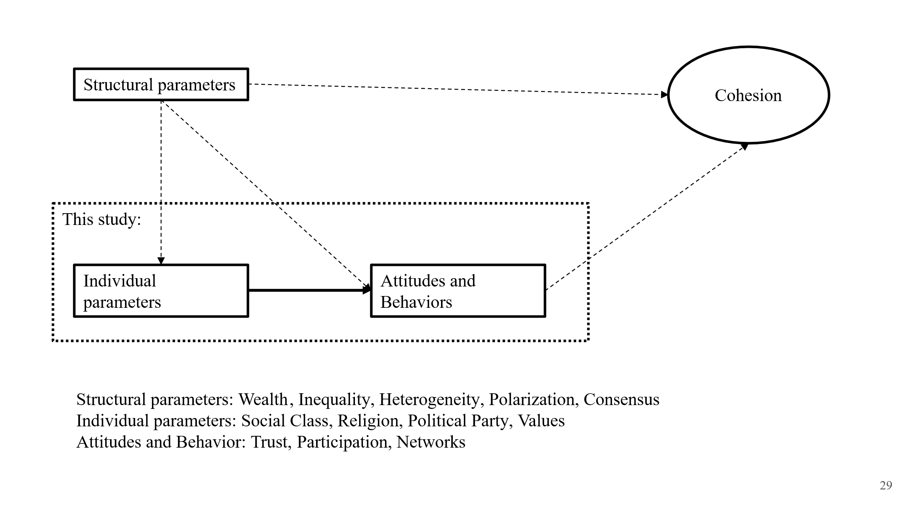
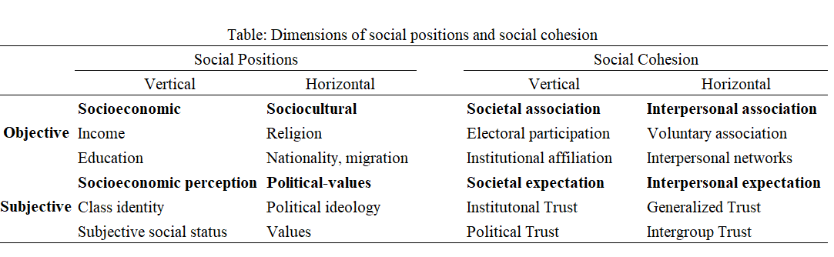

Hypotheses
H1 (socioeconomic)
Higher socioeconomic status people are more trustworthy
H2: (sociocultural diversity)
H2a: Religious people are more trustworthy than those without declared religious beliefs.
H2b: Migrants are less trustworthy than nationals
H3: (socio-political values)
Politically moderate people are more trustworthy than those people on the left and the right sides of the ideological spectrum.
People with self-transcendence values will be more trustworthy in contrast with those with self-enhancement values
H4: Same-group interactions are more trustworthy than cross-group interactions

